docker build -t ml-fastapi-app .
docker run -d -p 8000:8000 ml-fastapi-app
docker ps
docker stop <>
docker rm <>

http://127.0.0.1:8000/docs

Setup Branch Policies (Optional but recommended)
Go to Azure DevOps:
Repos → Branches → release → 3 dots → Branch Policies
Enable:
- Require PR before merging
- Minimum reviewers
- Check build (CI)
- Block direct pushes
- Require linked work item
This ensures release branch integrity.

This will push release branch on the remote
git push --set-upstream origin release

SET UP WITH REGISTERY

az group list --output table
az login
az configure --defaults group=fast-api-cicd
az acr login --name registeryfastapi
( select resource group and login with the azure registry)

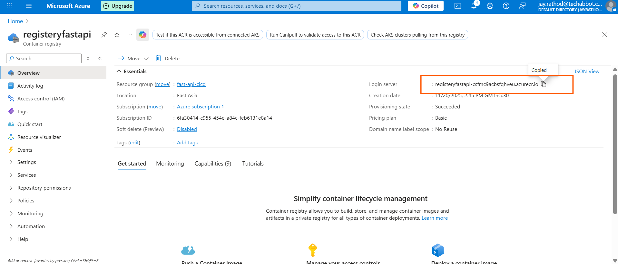

variables:
acrName: "registeryfastapi"
imageName: "ml-fastapi-app"
imageTag: "v1"
azureServiceConnection: "azure-sp-connection"
devWebApp: "your-dev-app"
prodWebApp: "your-prod-app"

$(az acr list --resource-group fast-api-cicd --query "[].name" --output tsv)
az acr repository list --name registeryfastapi --output table

$(az acr repository show-tags --name registeryfastapi --repository ml-fastapi-app)
az devops service-endpoint list --org https://dev.azure.com/{your_organization} --project {your_project}

push docker images to the remote registery

az login
az acr login --name <registry-name>
docker login <registry-name>.azurecr.io
docker tag yourimage:latest <registry-name>.azurecr.io/yourimage:latest

For verify
az acr repository show-tags \
--name registeryfastapi-csfmc9acbsfqhveu \
--repository ml-fastapi-app \
--output table

